1. Introduction to IOT systems:
1. The main characteristics of an Internet of Things application is that IOT devices and can be created to be specific to almost every industry and vertical, including healthcare, industrial automation, smart homes and buildings, automotive, and wearable technology. Increasingly, IOT applications are using AI and machine learning to add intelligence to devices & etc.
2. The 4 main components of the system in the simple IOT application architecture are
1) Use of sensors and actuators.
2) The internet gateway use of layers & data acquisition.
3) Edge information technology.
4) Use of clouds analytics and data centers.
3. Define the functionality of the following components:
1. Gateways connect devices within the Internet of Things to one another and to the cloud, translating communication between the devices and filtering data into useful information.
2. The role of big data in IOT is to process a large amount of data on a real-time basis and storing them using different storage technologies. A large amount of unstructured data is generated by IOT devices which are collected in the big data system.
3. It is a reusable functional unit of software owning data. A control application is specified by a “function blocks network” which can be distributed on one or more devices.
4. Device management is the process of managing the implementation, operation and maintenance of a physical and/or virtual device. It is a broad term that includes various administrative tools and processes for the maintenance and upkeep of a computing, network, mobile and/or virtual device.
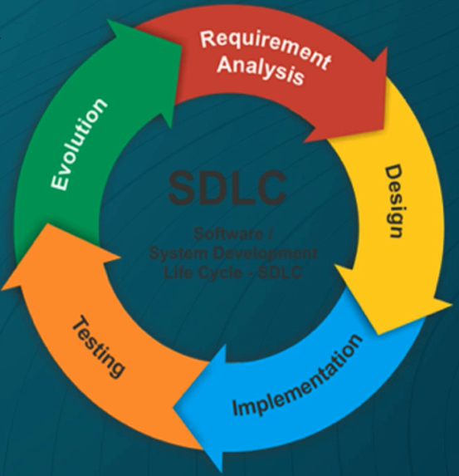
2. Define the main stages of the software development Life cycle, State the importance of using SDLC.

Main stages of Software Development Life Cycle
Importance of SDLC lifecycle
This is the most important part of the SDLC, people usually give more focus to designing and development and neglect the importance of requirement gathering due to which most of the software products have failed to meet the requirements.
3. State the advantages of having precise, documented software requirements during the software development life cycle.
The advantages of this model is that there is a working model of the system at a very early stage of development, which makes it easier to find functional or design flaws. Finding issues at an early stage of development enables to take corrective measures in a limited budget.
4. Define the difference between functional and nonfunctional requirements
A functional requirement defines a system or its component, A non-functional requirement defines the quality attribute of a software system. It specifies “what should the software system do?” it places constraints on “How should the software system fulfill the functional requirements.
5. State four important quality attributes that should be taken into consideration when designing software requirements documentation, stating the reason for each one.
1. Maintainability
2. Dependability and security
3. Efficiency
4. Acceptability/Usability
The four most important attributes are essentially maintainability, dependability, efficiency (performance) and usability. Other attributes that may be significant could be reusability (can it be reused in other applications), disreputability (can it be distributed over a network of processors), portability (can it operate on multiple platforms e.g. laptop and mobile platforms) and inter-operability (can it work with a wide range of other software systems).
6. Define the main stages of the attribute driven design process the inputs and the outputs of the process.
- Choose an element of the system to design
1. Select an element of the system that is not yet designed. In the first iteration this will be the system itself. Later on, a choice will need to be made between several elements. This choice can be based on personnel availability, input resources availability, risk mitigation, etc. In case you do not have any of these limitations, it is suggested to go for a breadth-first strategy.
- Identify the Architecturally Significant Requirements (ASR) for the chosen element
2. Identify the ASRs that are most important for this selected element. You should prioritize these requirements to make sure that your design reflects the most important ASRs.
- Generate a design solution for the chosen element
3. This step is the heart of ADD since the architecture will be created in this step. The architecture you create should reflect the selected ASRs. You can do this by making use of architectural patterns or tactics. Most of the times you will have to make a trade-off between several tactics and ASRs.
- Inventory remaining requirements and select the input for the next iteration
4. Take a look at the listed ASRs and see whether they are already fulfilled with the design you have at the moment. For each ASR you will have to check whether it is satisfied, delegated to one of the children, distributed among the children or whether it cannot be satisfied. In the last case you will need to change your architecture.
- Repeat steps 1-4 until all the ASRs have been satisfied

Required input
ADD can only be started successfully when the following resources are already available:
1. Functional requirements
4. Quality requirements
3. Constraints
7. What are the advantages of Multi-threating design?
The benefits of multi-threaded design can be broken down into four major categories:
- Responsiveness: Multithreading in an interactive application may allow a program to continue running even if a part of it is blocked or is performing a lengthy operation, thereby increasing responsiveness to the user.
- In a non-multi-threaded environment, a server listens to the port for some request and when the request. The time taken while processing of request and then resume listening to another request. The time taken while processing of request makes other users wait unnecessarily. Instead a better approach would be to pass the request to a worker thread and continue list of port.
8. Choose the correct answer:
1. In Multi-processing each process can be assigned to a different processor for its execution. If it’s a dual- core processor (2 processors), two processes can be executed simultaneously.
2. Multi-tasking refers to having multiple programs, processes, tasks, threads running at the same time.
9. Define the architecture Tradeoff Analysis Method and the outputs of the ATAM.
The Architecture Tradeoff Analysis Method (ATAM) is a method for evaluating software architectures relative to quality attribute goals.ATAM evaluations expose architectural risks that potentially inhibit the achievement of organizations business goals.
10. Define Five main components of the basic microcontroller structure.

A microcontroller can be seen as a small computer, and this is because of the essential components inside of it; the Central Processing Unit (CPU), the Random-Access Memory (RAM), the Flash Memory, the Serial Bus Interface, the Input/output Ports (I/O Ports), and in many cases, the Electrical Erasable Programmable Read-Only Memory (EEPROM).
11. The 32-bit microcontroller does not have program memory on the chip, so it needs an external memory peripheral.
12. What is the Arduino Shields and What functionality do they provide?
Shield is define as the hardware device that can be mounted over the board to increase the capabilities of the projects.it also makers our work easy.

